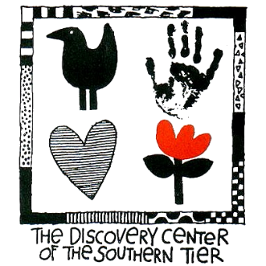
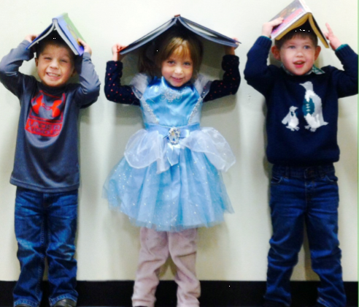
Discovery Kids Preschool
Discovery Kids Preschool at The Discovery Center of the Southern Tier respects each child as an individual and understands that each child has a unique way of learning. Our staff of early childhood teachers provide a warm, caring environment for children ages 3 and 4 to investigate, explore, play and learn. Children learn and develop in playful activities set among The Discovery Center’s engaging and dynamic hands-on
exhibits.
Universal Pre-Kindergarten (UPK)
Discovery Kids Preschool partners with The Binghamton City School District to offer a Universal Pre-Kindergarten Program. Children 4 years of age (by December 1) and residing within the City of Binghamton are eligible for tuition free enrollment in the UPK program. Discovery Kids UPK program is offered in the afternoon only (12:15-2:45PM), Monday through Friday. UPK follows a kindergarten readiness curriculum supplied by the Binghamton City School District and the State of New York. Enrollment for children residing in the City of Binghamton is limited to 19 students.
Extended Play
The Discovery Center has extended hours for our preschool friends! Extended Play gives children the opportunity to use their imaginations through dramatic role play and create fun arts and crafts. Children will enjoy exploring the museum and navigating through the Discovery Center’s Story Garden. For those families that opt for Extended Play, the hours are 2:45-5:15PM. Extended Play is not available on school holidays, however, it is open 11:30AM-5:15PM on half days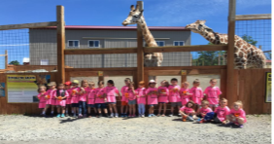
Preschool Hours
Half Day Preschool
Morning: 8:30-11:30AM
Afternoon (including UPK): 12:15-2:45PM
Full Day Preschool: 8:30AM-2:45PM
Lunch for full day students: 11:30AM-12:15PM
How to Register
To register for a preschool program, or schedule a tour please contact:
Kristy Wales, Director of Education
607-773-8861 Ext 209
DirectorofEd@thediscoverycenter.org
*Tuition is calculated based on 41 weeks (10 months) of school. Monthly rates are prorated as such.

At the Discovery Kids Preschool, we believe that early childhood should be a time of exploration and discovery. We want children to experience learning at this precious time of life in an atmosphere full of encouragement and filled with stimulation and imagination. We offer a balanced curriculum that focuses on play, creative art, music, outdoor play,
conversation, story time, experimentation, dramatic play, and group activities throughout a variety of thematic learning units.Play and learning flow together in a unique hands-on setting designed with imagination, research, and attention to the needs and spirit of today’s learners. Offering a safe, engaging, and happy atmosphere, the Discovery Kids Preschool fosters play, sparks creative thinking, and builds self-esteem. Continuing educational opportunities are paramount for all staff for their professional development. The ongoing education and growth mindset enhances their ability to provide the best possible experience for children. The Discovery Kids Preschool recognizes the need for families in our
community to enjoy a preschool experience in a safe, reliable, and healthy environment. It is our goal to provide a quality program that will benefit not only the child, but the family as well.

